Federal Student Loans Repayment Plans Overview*

Kamila Sommer, Simona Hannon and Jessica Hayes[1]

October 2013

*The analysis and conclusions set forth in this paper are those of the authors and do not indicate concurrence by other members of the research staff of the Federal Reserve System or its Board of Governors. References to this unpublished manuscript should be cleared with the authors to protect the tentative character of the work.

1. **Summary**

The growing prevalence of defaults and the deteriorating quality of student loan debt have attracted increasing attention from the public, media, and lawmakers. This paper reviews the federal repayment plans and uses two new data sources to analyze their affordability and take-up rates. First, we show that income-driven plans (primarily those based on demonstrated financial hardship) can be used by many borrowers to lower monthly payments on federal student loans to very low levels relative to borrowers’ incomes. We also argue that the definition of financial hardship is not difficult to meet, as even borrowers with very high incomes can qualify as long as their federal student loan balances are sufficiently high relative to those incomes. Second, we use new micro data for 2008-2009 college graduates to show that borrowers with very high student loan debt-to-income ratios have large exposures to private student loan debt and low incomes relative to their cohort average in the first year following college graduation. Because much of their student loan debt is concentrated in private student loans, available federal income-driven plans cannot be used to significantly reduce monthly payments for these borrowers.

1. **Federal Repayment Plans**

Federal student loan borrowers have access to several repayment plans that fall under two broad categories: (i) plans available to all borrowers and (ii) plans available only to borrowers with demonstrated financial hardship. In this section, we briefly review the existing plans and use repayment calculators provided by the Department of Education (DoEd) to compare the plans.[2] We also review the Loan Consolidation Program and the Loan Rehabilitation Program available to federal student loan borrowers.

* 1. **Plans Available to All Borrowers**

Amongst the plans available to all borrowers irrespective of whether they are able to document financial hardship (summarized in Table 1), there are four broad plan categories consisting of: (i) the **Standard** repayment plan, (ii) the **Graduated** repayment plan, (iii) the **Extended** repayment plan with fixed or graduated repayment schedule for borrowers with student loan balances in excess of $30,000, and (iv) the **Income-contingent** and **Income-sensitive** repayment plans.



1. The 10-year standard repayment plan is a fully amortizing plan with fixed monthly payments that is associated with the lowest total interest payments amongst the repayment plans. While the plan represents the least expensive way of financing college debt, owing to its short maturity and fixed-payment schedule, it is also typically associated with higher monthly payments than the other plans and offers no flexibility to adjust monthly payments.
2. The 10-year graduated repayment plan offers a graduated payment schedule and is particularly convenient for borrowers expecting income growth over time. The plan is fully amortizing, with low initial payments that rise over time. Payment adjustments occur every two years.
3. The 25-year extended repayment plans offer fixed or graduated payment schedules (per the borrower’s selection) for those borrowers with high student loan balances (in excess of $30,000) who seek loan maturities beyond the standard 10-year repayment schedule. Due to the extended amortization schedule, this plan offers lower monthly payments than the 10-year repayment plans.
4. The 25-year income-contingent repayment (ICR) plan (for Direct loans) or 10-year income-sensitiverepayment (ISR) plan (for FFELP loans) offer repayment schedules that are tied to the borrower’s income.[3]

Under the ICR plan, monthly payments and the amortization schedule are adjusted every year and are based on borrower’s income, family size, and loan amount. Borrowers with high student loan debt-to-income (DTI) ratios are offered longer maturity windows and lower monthly payments than borrowers with lower student loan DTI ratios. Moreover, a borrower’s maximum monthly payment is capped at 20 percent of her monthly discretionary income.[4] Borrowers have up to 25 years to repay their loans, after which, if they made the equivalent of 25 years of qualifying payments, the unpaid balance is forgiven.[5]

Under the ISR plan, monthly payments are based on annual income and up to a 10-year amortization schedule. The monthly payment formula under this plan varies by lender.

Table 2 compares the standard, graduated, and extended plans for a hypothetical undergraduate dependent borrower who has borrowed the maximum amount of federal student loans ($31,000).[6] As can be seen in Table 2, the 10-year standard repayment plan carries the lowest total interest paid ($11,810), followed by the 10-year graduated repayment plan ($15,068). In this example, the extended repayment plans more than double the total interest paid by the borrower over the repayment period ($33,548 and $38,931 for the extended plan with fixed payments and graduated payments, respectively). Notably, each plan is fully amortizing over its repayment maturity, with – all else equal – the total interest paid and repayment window being independent of borrower’s income.



In contrast, Table 3 shows the repayment terms for the same borrower with an ICR plan by borrower’s adjusted growth income (AGI) under the assumption that borrower’s income does not change over the repayment period.[7] Interestingly, while monthly payments increase monotonically with borrower’s income, the total interest paid follows an inverse U-shape: Total interest paid in this example is $0 for a borrower with an AGI of $6,000 or less, peaks at nearly $27,000 for a borrower with an AGI of $24,000, and declines to about $10,000 for a borrower with an AGI of $90,000. The inverse U-shape of total interest paid over borrower AGI partially reflects how the repayment period declines with borrower AGI. For example, a borrower with an AGI of $80,000 would repay her loan 8 months sooner with the ICR plan than with the 10-year standard repayment plan.



In addition, the ICR plan offers borrowers the option of debt forgiveness after 25 years of qualifying payments. For example, in the extreme case in which a borrower has no income for the entire 25-year repayment period, all of the principle and interest would be forgiven. Similarly, a borrower with an AGI of $10,000 would repay less than a quarter of the total paid by a borrower with a 10-year plan. That said, a borrower with an AGI of only $24,000 would pay more than double the total interest than with the 10-year standard repayment plan. Therefore, while the ICR plan can be used by lower-income borrowers to reduce their monthly student loan payments (relative to other repayment plans), the loan forgiveness takes effect only under fairly dire economic circumstances.[8]

* 1. **Plans Available to Borrowers with Demonstrated Financial Hardship**

Two plans (summarized in Table 4) are available for borrowers with demonstrated financial hardship: (i) the Income-Based Repayment (IBR) plan and the (ii) Pay-As-You-Earn (PAYE) repayment plan (the latter of which is available only for Direct loans).[9] While the two plans vary in some of the eligibility requirements, they both offer low income-based payments that are set at 15 and 10 percent of discretionary income and 25- and 20-year amortization periods, respectively. Similar to the ICR plan discussed above, these plans have payment schedules that adjust with borrower AGI. These plans offer the lowest monthly payments of all the repayment plans, thereby increasing affordability. However, the low monthly payments translate into longer maturities and therefore larger total interest payments. That said, similar to the ICR plan, these plans offer the option of debt forgiveness after 25 and 20 years of qualifying payments, respectively, although the amount forgiven may be subject to income tax.[10]



A borrower’s ability to demonstrate financial hardship for the IBR and PAYE plans lies in her ability to demonstrate that her federal student loan debt-to-income ratio is below the eligibility cutoffs.[11] The cutoffs are set so that after they are exceeded, a borrower would be better off on a 10-year standard repayment plan, with both the monthly payment and the total interest paid below that of the IBR or PAYE plans. Figure 1shows monthly payments by borrower AGI as well as how the eligibility cutoffs vary with a borrower’s income and loan amount for the IBR and PAYE plans. An undergraduate borrower with $12,000 in student loans qualifies for the two programs only if her income does not exceed $28,000 for the IBR and $33,000 for the PAYE plans, respectively. In contrast, an undergraduate borrower with the maximum $31,000 of federal student loans qualifies with a significantly higher income not to exceed $45,000 and $60,000 respectively. Finally, a graduate borrower with a maximum amount of Stafford loan balance of $138,500 would qualify for the programs as long as her income does not exceed $144,000 and $208,000 under the IBR and PAYE plans, respectively. Interestingly, once a borrower qualifies for the program, she is eligible to continue making payments even as her income rises above the levels initially needed to qualify for the program. In our view, our findings demonstrate that the definition of financial hardship is not hard to meet, as even borrowers with very high incomes can qualify for the IBR and PAYE plans as long as their federal student loan balances are sufficiently high relative to those incomes.

**Figure 1: Monthly Repayment Amounts by Borrower AGI and Income Eligibility Cut-offs for the IBR, PAYE and Standard Repayment Plans**

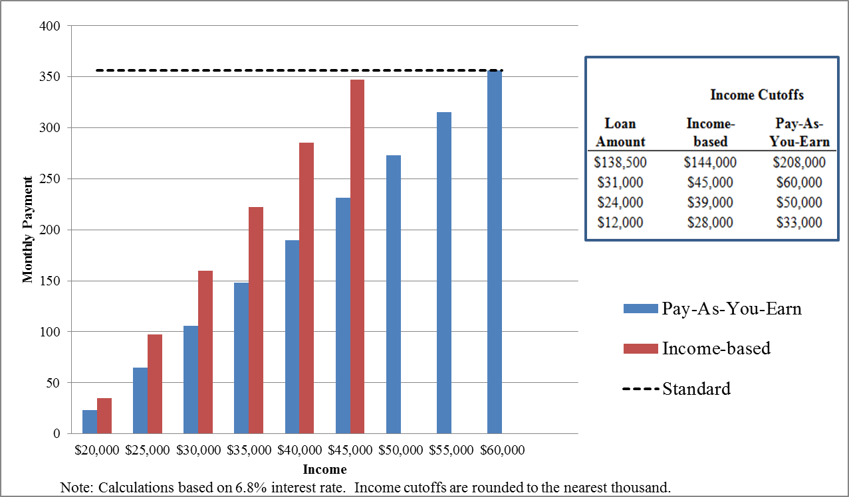

* 1. **Switching between Plans, Loan Consolidation, and Loan Rehabilitation**

Although a repayment plan is selected when a borrower first begins repaying the student loans, the plan can be changed at any time per DoEd guidelines.

Furthermore, outstanding federal loans can be consolidated under the **Loan Consolidation Program**, with the interest rate on the resulting consolidation loan calculated as the weighted average interest rate (capped at 8.25 percent) of the consolidated loans. The repayment term varies between 10 to 30 years, depending on the amount of the consolidation loan, other education debt, and the repayment plan selected. Borrowers can choose from multiple plans to repay their Consolidation loan, including the ICR and IBR plans. Since 2007, consolidated loans are issued as Direct loans and, as a result, qualify for the PAYE plan (except for Consolidation loans that repaid Parent Plus loans). As with regular loans, borrowers can switch between repayment plans at any time without costs.[12]

Although loan consolidation generally applies only to loans in repayment or a grace period, the federal government may allow holders of troubled federal student loans that are either in deferment, forbearance, or default to consolidate their loans as part of the Loan Consolidation Program, with the newly consolidated loan being put on an income-driven plan such as the IBR or PAYE plans. A borrower is typically required to make at least three consecutive, voluntary, and on-time payments prior to consolidation of a defaulted loan. The option to consolidate defaulted loans is a part of the **Loan Rehabilitation** **Program**. For individual loans that are not considered for a consolidation, the borrower and the lender (or the DoEd servicer, if the borrower has defaulted on a Direct loan) agree on a reasonable repayment plan for nine consecutive payments over a 10-month period. The loan is considered “rehabilitated” and the default status is cleared once all payments have been made on time and a lender has purchased the loan.[13] With a rehabilitated loan, consumers may be eligible for deferment, forbearance, or other repayment options.

* 1. **Public Service Loan Forgiveness**

The Public Service Loan Forgiveness Program (PSLFP) is intended to encourage individuals to enter and continue to work full-time in public service jobs.[14] According to the Consumer Financial Protection Bureau, about a quarter of the labor force in 2010 was employed in qualifying jobs, representing about 10 million individuals.[15] Under this program, borrowers may qualify for forgiveness of the remaining balance of their Direct loans after they have made 120 qualifying payments while employed full time by certain public service employers. Only Direct loans with payments beginning after October 1, 2007, qualify, so borrowers would be eligible for loan forgiveness starting October 2017.[16]

To maximize forgiveness under the PSLFP starting in 2017, borrowers could repay their loans under the ICR, IBR, or PAYE plans. Under these plans, a borrower is able to lower the monthly payment relative to the 10-year standard repayment plan. At the same time, the additional interest accumulated due to the extended repayment window as well as the outstanding loan balance after 10 years of payments would be forgiven under the PSLFP. However, if a borrower ultimately does not meet the eligibility requirements for PSLFP at the time of application (starting in 2017), the borrower will be responsible for repaying the entire balance of the loan, and ultimately paying more in total interest payments than with the 10-year standard repayment plan.

1. **Affordability of Student Loan Payments**
   1. **Using Income-Driven Plans to Reduce Monthly Payment Burden**

A number of studies on student loan affordability posit that students should not devote more than 8 percent of their gross income to the repayment of student loans.[17] The Illinois Student Assistance Commission (2001) noted that the literature includes guidelines ranging from 5 to 15 percent of gross income, but accepted an 8-percent rule as the consensus standard. The Government Accountability Office (2003) cited 10 percent of first-year income as the generally agreed-upon standard. In some studies, the 8-percent rule has also been used to calculate the number of students with unmanageable or excess student loan burden (King and Bannon, 2002, Heller, 2001, and Harrast, 2004).

Table 5 summarizes the portion of gross income devoted to student loan repayment, by borrower income, for the 10-year standard, 25-year extended, and income-driven (ICR, IBR, and PAYE) repayment plans. While student loan debt-to-income (DTI) payments can be quite high for borrowers with lower incomes under the 10-year standard repayment plan, the income-driven repayment plans (those based on demonstrated financial hardship, in particular) provide an affordable financing option for all borrowers even when their federal student loan balances are high. In particular, for dependent undergraduate, independent undergraduate, and graduate borrowers with a maximum amount of federal student loan debt, student loan DTI ratios do not exceed 9, 11, and 13 percent, respectively. As noted previously, since the IBR and PAYE plan income limits are set so that a borrower qualifies for these programs up to a point where she would be better off with a 10-year standard repayment plan, these plans are available to federal student loan borrowers to reduce their payments to affordable levels.



* 1. **Take-up Rates**

Table 6 summarizes federal student loan participation statistics for Direct loans provided by the DoEd. Unfortunately, statistics for FFELP loans are not readily available, as the DoEd does not hold these loans on their portfolio. Among Direct loans, the income-driven (ICR, ISR, IBR and PAYE) plans are currently used by 11 percent of borrowers to repay about 20 percent of Direct loans outstanding that are in repayment. Over 60 percent of student loan borrowers elect to repay their loans under the 10-year standard repayment plan. Interestingly, over the past year, the number of Direct loan borrowers in the IBR plan has markedly increased. The increase may be due to an increase in the take-up of the IBR plan due to heightened awareness and improved understanding of the existing programs as well as to the release of an electronic application for the plan. Furthermore, students appear to take advantage of the PAYE plan, which is a relatively new plan, as of December 2012. In less than a year, about 40,000 students enrolled in the PAYE plan.



* 1. **Affordability of Student Debt: Evidence from Micro Data**

In this section, we use estimates from the Baccalaureate and Beyond (B&B) 2008-09 survey to draw inferences about the exposure of graduating college seniors to student loan and other debt. The B&B is a 2-year panel survey conducted by the National Center for Educational Statistics (NCES) that interviewed about 15,000 students who received their bachelor’s degrees in 2007-08, and re-interviewed each student one year after graduation.

Table 7 summarizes the distribution of the monthly student loan repayments as a percent of respondents’ incomes in 2009 by respondents’ ages for individuals with student loans. Interestingly, the median student loan DTI ratio is 8 percent – the golden rule for student loan exposure. However, the student loan DTI ratio for the top quartile of the student loan DTI distribution is estimated at 14 percent. For the top decile, the student loan DTI ratio is estimated at 25 percent – roughly on par with typical recommendations for rent or mortgage DTI ratios.

The lower two panels show the distributions for borrowers with and without income-driven repayment plans, respectively. Interestingly, while our previous analysis suggests that borrowers with income-driven repayment plans should have significantly lower student loan DTI ratios relative borrowers without income-driven plans, the available data points to only a small difference between the two groups.



Table 8 shows the average estimates for total and federal student loan amounts owed at the time of college graduation in 2007-08, estimated monthly earnings in 2009, monthly rent/mortgage and car payments in 2009, and estimated DTI ratios for these payments by student loan DTI ratio and income-driven repayment plan.

Two key messages emerge from the table:

1. Borrowers with student loan DTI ratios in line with the “golden-rule” (i.e., below 10 percent) spend over 30 percent of their gross income on mortgage or rent payments and nearly 10 percent on car payments. Abstracting from other debt obligations such as credit card debt (for which the survey does not collect information), total DTI ratios are estimated at about 50 percent. This is more than the recommended 36-45 percent total DTI ratio currently imposed by many mortgage lenders.
2. Student loan borrowers with student loan DTI ratio in excess of 20 percent tend to have much higher DTI ratios for mortgage/rent and car payments than borrowers with lower student loan DTI ratios. Moreover, borrowers with student loan DTI ratios exceeding 30 percent spend well over 100 percent of their monthly income on rent, mortgage, car, and student loan payments. These borrowers also tend to have large amounts of non-federal (i.e., private) student loans, inferred as the difference between total and federal student loan debt. Moreover, these borrowers have very low monthly income in the first year after graduation relative to the cohort average.

In summary, borrowers with high exposures to student loan debt relative to their incomes in the first year after graduation have monthly earnings well below those of students with lower student loan DTI ratios.[18] Since income-driven plans are typically associated with federal student loans, the high exposure to private student debt partially explains why participation in income-driven plans for these students does not drastically reduce their student loan monthly obligations. Documenting the availability and dissemination of information related to income-driven repayment plans in the private market would be, in our view, a fruitful avenue for future studies.

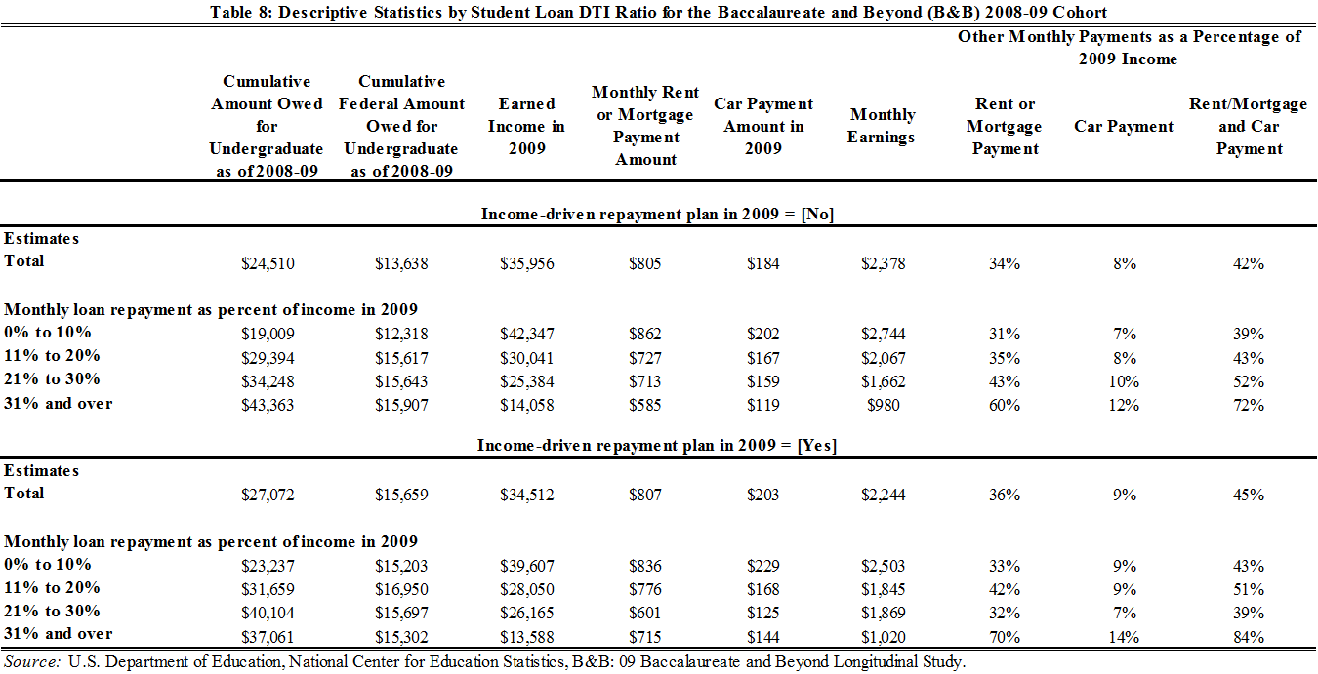

1. **Conclusion**

This paper reviewed the available federal student loan repayment plans. We showed that income-driven plans (particularly those based on demonstrated financial hardship) can be used by many borrowers to lower monthly payments on federal student loans to very low levels relative to borrowers’ incomes, and can even be used to rehabilitate loans in default. At the same time, we argued that the definition of financial hardship is not difficult to meet, as even borrowers with very high incomes can qualify as long as their federal student loan balances are sufficiently high relative to those incomes. New micro data for 2008-2009 college graduates shows that recent borrowers with very high student loan balances relative to their incomes have large exposures to private student loan debt and low incomes relative to the cohort average in the first year following college graduation. Since much of their student loan debt is concentrated in private student loans, available federal income-driven plans cannot be used to significantly reduce monthly payments for these borrowers. Given our estimates of high private student loan exposure in the recent data, we believe that exploring the availability and dissemination of information related to income-driven repayment plans in the private market would be a fruitful avenue for future research.

1. We thank Alvaro Mezza for helpful feedback. We also thank Gage Love for excellent research assistance.
2. The calculators for the respective plans described in this document can be located at: http://studentaid.ed.gov/repay-loans/understand
3. The ICR plan was originally designed to increase affordability of student loan financing for borrowers in jobs that have low initial incomes that grow significantly over time.
4. Discretionary income is calculated as the difference between the adjusted gross income and 150 percent of the gross poverty guideline for the specific family size and state of residence (other conditions apply).
5. The forgiven amount may be subject to income tax. Moreover, if the calculated payment amount is less than the amount of interest that accrues on the loan, the interest is capitalized to the principal balance once each year until the balance is 10 percent higher than the original loan balance when repayment started. Once this happens, interest continues to accrue but is not capitalized.
6. The total aggregate limit for an undergraduate independent borrower is $57,500. For graduate students, the total aggregate limit for Stafford loans is $138,500. The estimated monthly payments and student loan DTIs in Tables 2, 3 and 5 and Figure 1 are based on a 6.8 interest rate, the rate on Unsubsidized Stafford student loans rate prior to the passage of the “Student Loan Certainty Act” legislation in August 2013.
7. AGI is defined as a family's (own and spouse’s) wages, salaries, interest, dividends, etc., minus certain deductions from income as reported on its federal income tax return.
8. This statement has to be, however, interpreted in a context of other factors. For example, a borrower who has made 20 years of qualifying payments with an ICR plan and then becomes suddenly unemployed and stays unemployed for 5 years would also have the remaining loan balance and outstanding interest forgiven. Moreover, commentators noted that the debt forgiveness embedded in the federal income-driven plans can greatly benefit high-income borrowers with large student loan balances, primarily if their incomes start relatively low and rise rapidly over the repayment period (see, Delisle and Holt, 2012, “Safety Net or Windfall? Examining Changes in Income-Based Repayment for Federal Student Loans”).
9. The definition of financial hardship varies across the two plans. For the IBR plan, financial hardship is defined as a circumstance in which the annual amount due on eligible loans with a 10-year standard repayment plan exceeds 15 percent of the difference between the borrower’s AGI and 150 percent of the poverty line for her family size in her state of residence. For the PAYE plan, financial hardship is defined as a circumstance in which the annual amount due on eligible loans under a 10-year standard repayment plan exceeds 10 percent of the difference between the borrower’s AGI and 150 percent of the poverty line for her family size in her state of residence. For both plans, the amount that would be due under a 10-year standard repayment plan is calculated based on the greater of the amount owed on eligible loans when the borrower originally entered repayment, or the amount owed at the time the borrower selected an IBR of PAYE plan.
10. Furthermore, under the income-based plans, borrowers can be vulnerable to negative amortization issues if their monthly payment does not fully cover the interest accrued on the loan.
11. To qualify for the PAYE plan, applicants must additionally be new borrowers on or after October 1, 2007 and must have received a disbursement of a Direct loan on or after October 1, 2011.
12. Source: http://loanconsolidation.ed.gov/help/faq.html
13. Other benefits of loan rehabilitation include the removal of the default status reported to the national credit bureaus, wage garnishment, and any withholding of income tax refunds made by the Internal Revenue Service.
14. Qualifying employment is any employment with a federal, state, or local government agency, entity, or organization or a not-for-profit organization that has been designated as tax-exempt by the Internal Revenue Service (IRS) under Section 501(c)(3) of the Internal Revenue Code (IRC). The type or nature of employment with the organization does not matter for PSLFP purposes. Additionally, the type of services that these public service organizations provide does not matter for PSLFP purposes. A private not-for-profit employer that is *not* a tax-exempt organization may be a qualifying public service organization if it provides certain specified public services. These services include emergency management, military service, public safety, or law enforcement services; public health services; public education or public library services; school library and other school-based services; public interest law services; early childhood education; public service for individuals with disabilities and the elderly. The organization must not be a labor union or a partisan political organization. 
15. CFPB August 2013: “Public Service & Student Debt”.
16. FFELP loans or Perkins Loan Program loans must be consolidated into a Consolidation loan to take advantage of PSLFP; however, only payments on the newly consolidated loan count as qualifying payments. Additionally, for Direct loans that are further consolidated into a Consolidation loan, a borrower must make 120 qualifying payments on the Consolidation loan before applying for qualifying for PSLFP.
17. See “How Much Debt Is too Much?” (2006) by Sandy Baum and Saul Schwartz for a review.
18. Differences in monthly earnings were not influenced by unemployment or non-participation spells: The interviewed graduates had uniformly spent 82-88 percent of the time between their graduation and the 2009 interview on working, while the follow-up interview took place on average between 13 and 16 months following the graduation across the student loan DTI ratio categories shown in Table 6.